* SQL is a standard language for accessing and manipulating databases.
* SQL became a standard of the American National Standards Institute (ANSI) in 1986, and of the International Organization for Standardization (ISO) in 1987

Using SQL in Your Web Site

To build a web site that shows data from a database, you will need:

* An RDBMS database program (i.e. MS Access, SQL Server, MySQL)
* To use a server-side scripting language, like PHP or ASP
* To use SQL to get the data you want
* To use HTML / CSS to style the page
* **PHP** is a recursive acronym for "**PHP**: Hypertext Preprocessor". · **PHP** is a server side scripting language that is embedded in HTML.
* RDBMS stands for Relational Database Management System.
* RDBMS is the basis for SQL, and for all modern database systems such as MS SQL Server, IBM DB2, Oracle, MySQL, and Microsoft Access.
* Every table is broken up into smaller entities called fields. The fields in the Customers table consist of CustomerID, CustomerName, ContactName, Address, City, PostalCode and Country. A field is a column in a table that is designed to maintain specific information about every record in the table.
* A record, also called a row, is each individual entry that exists in a table. For example, there are 91 records in the above Customers table. A record is a horizontal entity in a table.
* A column is a vertical entity in a table that contains all information associated with a specific field in a table.
* 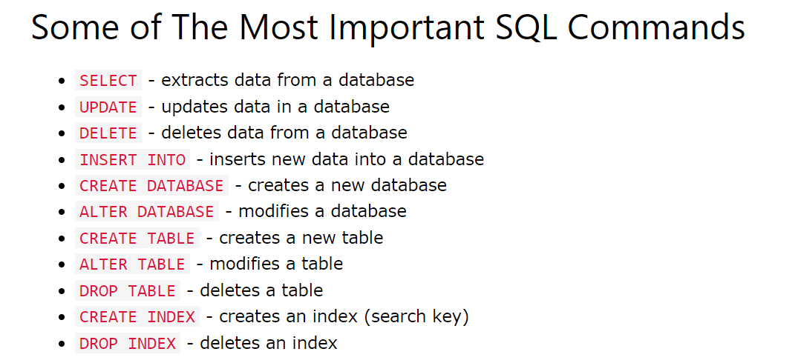
* Logical schema == DB schema